**Nalaiya Thiran**

**Assignment – 3**

**Done By:** ArunPriyan.K **Team ID:** PNT2022TMID17812

**Roll No:** 9517201904250

**1.Blinking Led:**

**Source Code:**

import RPi.GPIO as GPIO

from time import sleep

GPIO.setmode(GPIO.BOARD)

GPIO.setup(7, GPIO.OUT)

while True:

GPIO.output(7, GPIO.HIGH)

print(“LED On”)

sleep(1)

GPIO.output(7, GPIO.LOW)

sleep(1)

print(“LED Off”)

**Output:**

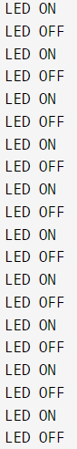

**2. Traffic Signal:**

**Source Code:**

from gpiozero import TrafficLights

from time import sleep

lights = TrafficLights(10, 9, 11)

while True:

light.red.off()

light.green.on()

print(GREEN)

sleep(1)

light.green.off()

lights.amber.on()

print(AMBER)

sleep(1)

lights.amber.off()

light.red.on()

print(RED)

sleep(1)

**Output**:

